**LAB 5**

**OBJECTIVE**

To be familiar with basic JavaScript.

**DESCRIPTION**

JavaScript (JS) is a lightweight, interpreted, or just-in-time compiled programming language with first-class functions. While it is most well-known as the scripting language for Web pages, many non-browser environments also use it, such as Node.js, Apache CouchDB and Adobe Acrobat. JavaScript is a prototype-based, multi-paradigm, single-threaded, dynamic language, supporting object-oriented, imperative, and declarative (e.g. functional programming) styles.

It is a full-fledged dynamic programming language that, when applied to an HTML document, can provide dynamic interactivity on websites. Like CSS, Javascript code should be placed in its own file. Javascript files have a .js extension. To run the .js file in an HTML page the javascript file should be referenced using a <script> HTML tag.

**HTML**

<!DOCTYPE html>

<html>

<head>

<title>Javascript Tutorial</title>

<script type="text/javascript" src="js/script.js"></script>

</head>

<body>

<h2 id="title">Page title</h2>

<ul class="news">

<li>First Item</li>

<li>Second Item</li>

<li>Third Item</li>

</ul>

<button id="button">Change</button>

</body>

</html>

**JavaScript**

alert("Hello World!");

var check = confirm("Do you really want to delete?");

alert(check);

var name=prompt("Enter your name: ");

if (name != null && name!='')

console.log('Hello '+name);

function mouseEnter()

{

var title = document.getElementById("title");

title.style.color = "red";

}

function mouseLeave()

{

var title = document.getElementById("title");

title.style.color = "black";

}

function changeItems()

{

var news = document.getElementsByClassName("news");

var items = news[0].getElementsByTagName("li");

for (var i = 0; i < items.length; i++)

{

var value = i + 1;

items[i].innerHTML = "Item " + value;

}

}

function myLoad()

{

var title = document.getElementById("title");

title.addEventListener("mouseenter", mouseEnter);

title.addEventListener("mouseleave", mouseLeave);

var button = document.getElementById("button");

button.addEventListener("click", changeItems);

}

document.addEventListener("DOMContentLoaded", myLoad);

**OUTPUT**

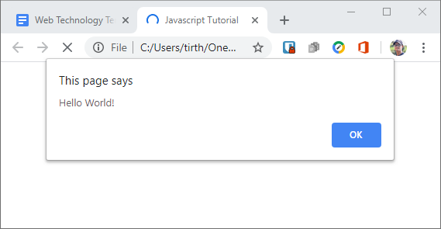

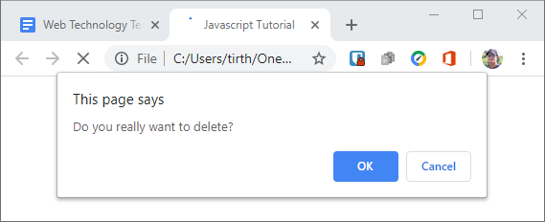

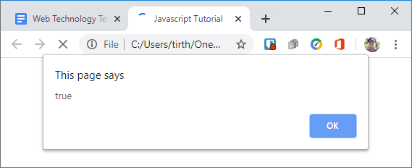

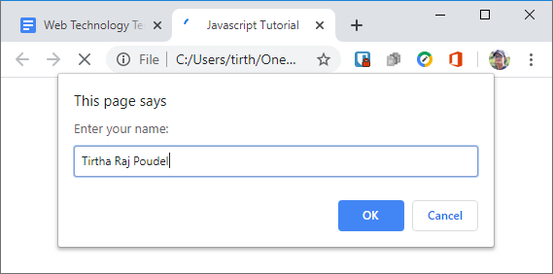

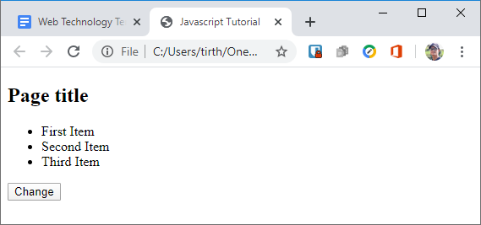

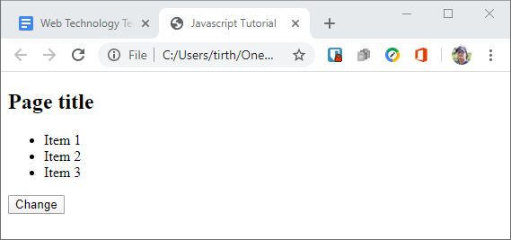

**SUMMARY**

In this lab, I got familiar with basic Javascript syntax and used it to create different alert, confirm and prompt boxes and wrote a simple program to overwrite the content of our simple web page.

**COMMENT**